PROJECT DOCUMENTATION

1. INTRODUCTION
Project Title: MICROGOAL (BACKEND)
Team ID: SWTID-2026-5643
Team Leader:
Name : priya Dharshini .R& Mail ID: priyaramesh231106@gmail.com
[Coder]
Team Members:
Name : Nandhini.V & Mail ID: nanxx2143@gmail.com
[Documentation]
Name : Navi.B: navi4092006@gmail.com
[Editing]
Name : Rajakumari.B & Mail ID: rajakumarib971@gmail.com

[Documentatiom]

2. PROJECT OVERVIEW
Purpose:
Micro Goals is a secure backend REST ful API developed using Node.js, Express.js, and Mongo DB. The application is designed to help users efficiently manage their personal goals in a secure and organized manner.
It provides a robust backend system that allows users to register, authenticate, and perform complete CRUD (Create, Read, Update, Delete) operations on their goals.
The system implements JWT (JSON Web Token)–based authentication to ensure secure access and protect user data. Each user can only access and manage their own goals, ensuring privacy and user-specific data control.

Features:
User Registration &amp; Login
JWT-based Authentication
CRUD Operations for Goals
Protected Routes

3. ARCHITECTURE

FRONTEND
- HTML
- CSS
- JavaScript
- Bootstrap
- Material UI

BACKEND
- Node.js
- Express.js
- RESTful API
- Business Logic

DATABASE
- MongoDB
- User Data
- Fitness Data
- Chat Message

4. SETUP INSTRUCTIONS
Prerequisites:
Before running the project, the following tools are required:
● Node.js (v18 or higher)
● Express.js
● MongoDB (Local )
● VS Code
● Thunder Client (Extension)
● Basic knowledge of JavaScript &amp; REST APIs

5. TECHNICAL ARCHITECTURE

Runtime: Node.js
Framework: Express.js
Database: MongoDB
Authentication: JWT
Architecture Pattern: MVC
Features:
● User Registration
● Secure Login with JWT
● Create Goal
● Update Goal
● Delete Goal
● View User-specific Goals
● Protected Routes

6. Folder Structure

MicroGoals/
├── middleware/
│ ├── authMiddleware.js
│ └── errorMiddleware.js

├──Schema/
├──User.js
├──GoalSchema.js
├── models/
│ ├── userModel.js
│ └── goalModel.js
│
├── routes/
│ ├── authRoutes.js
│ └── goalRoutes.js
│
├── .env
├── Index.js
└── package.json

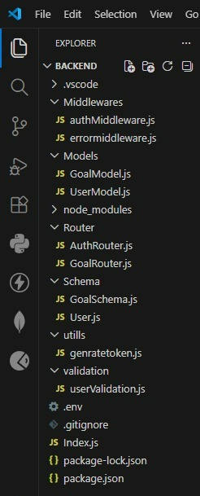
Setup For Run An Program
1. npm start
2. Install dependencies:
npm install express mongoose json webtoken bcryptjs dotenv
3. Start server:
node Index.js

7. BACKEND DEVELOPMENT
For the backend development of the project, an Express.js server was created using Node.js.
The Express server acts as the core component that handles communication between the frontend and the backend.
The server was configured to manage API requests, connect different routes, and process data efficiently
Middleware was implemented to enable JSON parsing, allowing the server to receive and interpret data sent from the client side.

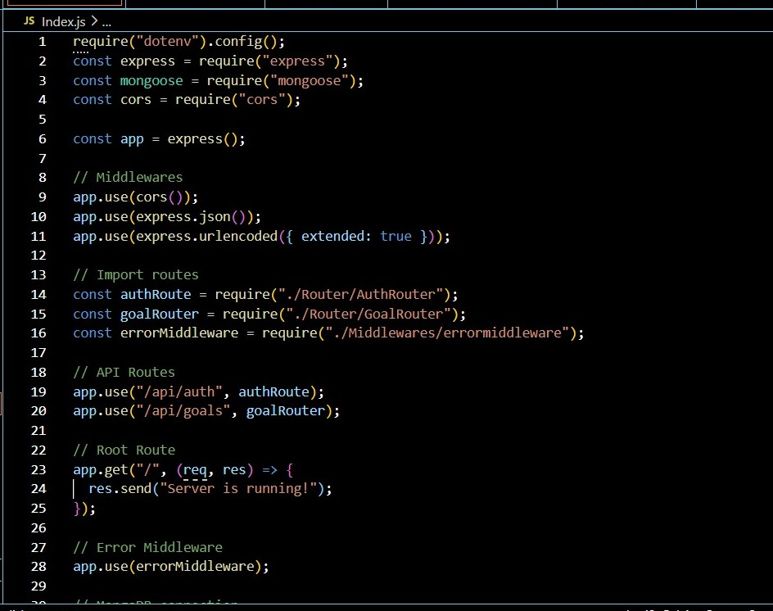

Connected MongoDB
- For Connection with MongoDB:-Install dependencies
-npm install

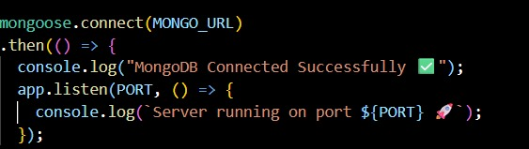

8. Implemented Authentication APIs
Authentication APIs were implemented to ensure secure user access and protect application resources. The APIs allow users to register, log in, and access authorized features of the system.
KEY POINTS:
• User Registration Endpoint:
An API endpoint was created to allow new users to sign up by providing required details such as name, email, and password.
• Input Validation:
User input was validated to ensure that required fields are provided and formatted correctly before processing the request.
• Protected API Routes:
Sensitive endpoints were restricted and can only be accessed with a valid authentication token.

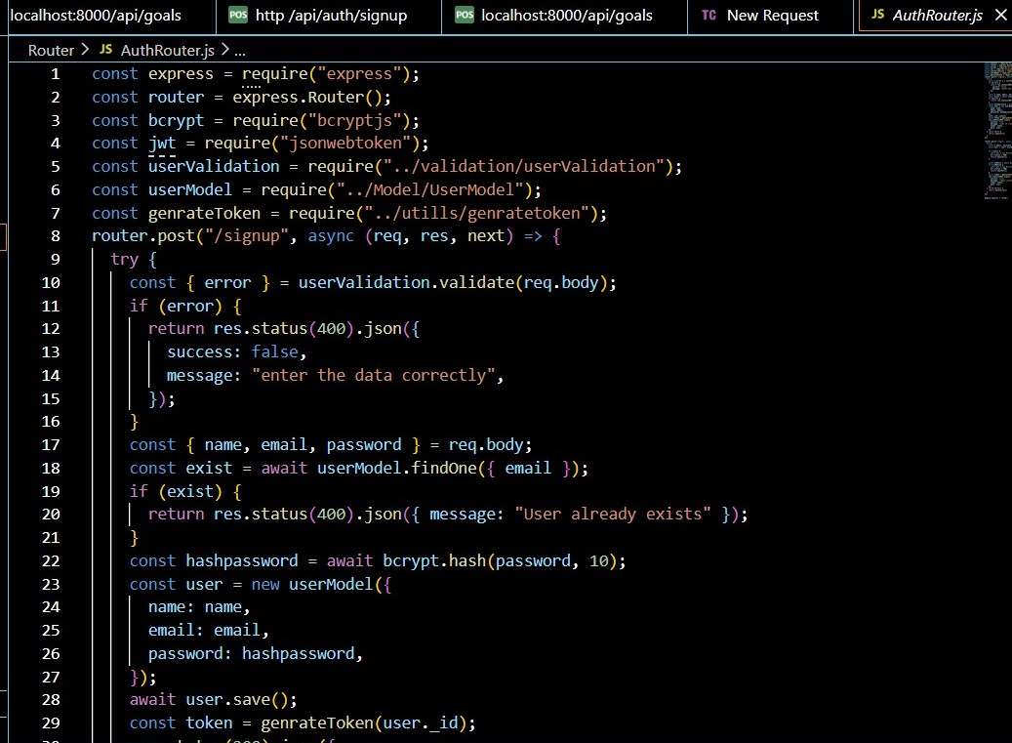

9. Implemented Goal CRUD APIs
Goal CRUD APIs were developed to enable authenticated users to perform Create, Read, Update, and Delete (CRUD) operations on their personal goals. These APIs follow REST ful architecture principles, ensuring organized, scalable, and efficient communication between the client and server.
Create Goal API:
An API endpoint was implemented to allow users to create and store new goals in the database. Each goal is linked to the respective user using a user Id reference, ensuring that goals remain associated with the correct user.
Read Goals API:
The Read API allows authenticated users to retrieve the list of goals they have created. Data filtering is applied based on the authenticated user’s ID to ensure that users can only access their own data.
Update Goal API:
The Update API enables users to modify the details of an existing goal. Validation checks are applied to confirm that only the owner of the goal has permission to update it.
Delete Goal API
The Delete API allows users to remove goals from the database permanently. Authorization checks ensure that users cannot delete goals created by other users.
Authentication Protection:
All CRUD endpoints are secured using authentication middleware that verifies tokens generated through JSON Web Token. If the token is missing or invalid, the system returns a 401 Unauthorized response.
Backend Framework:
These APIs were developed using Express.js running on Node.js, ensuring a scalable and efficient backend system.

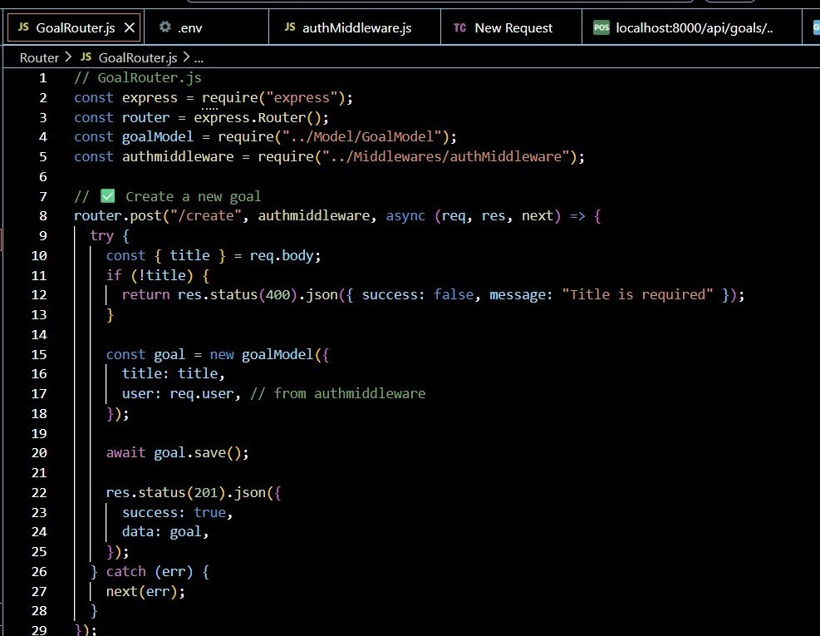
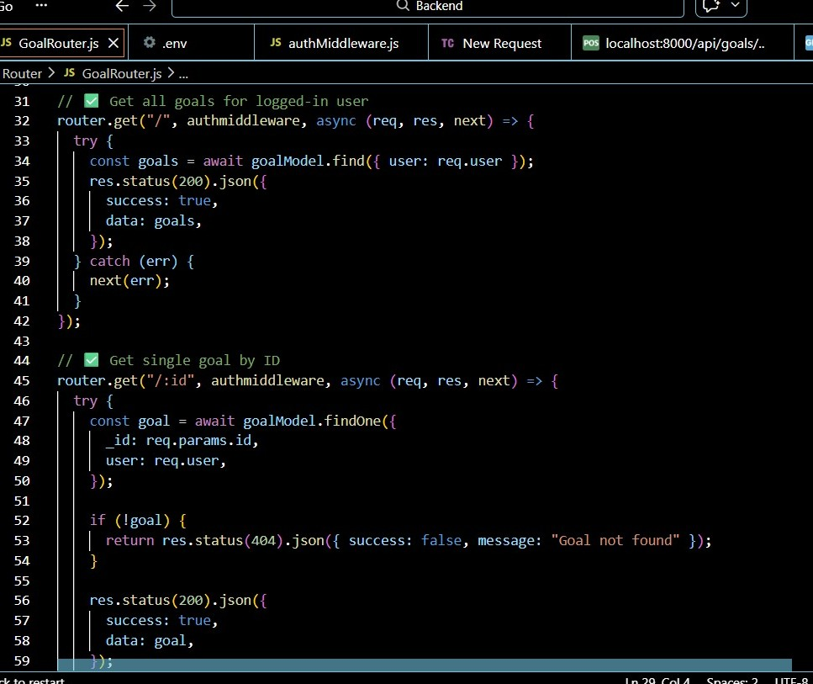

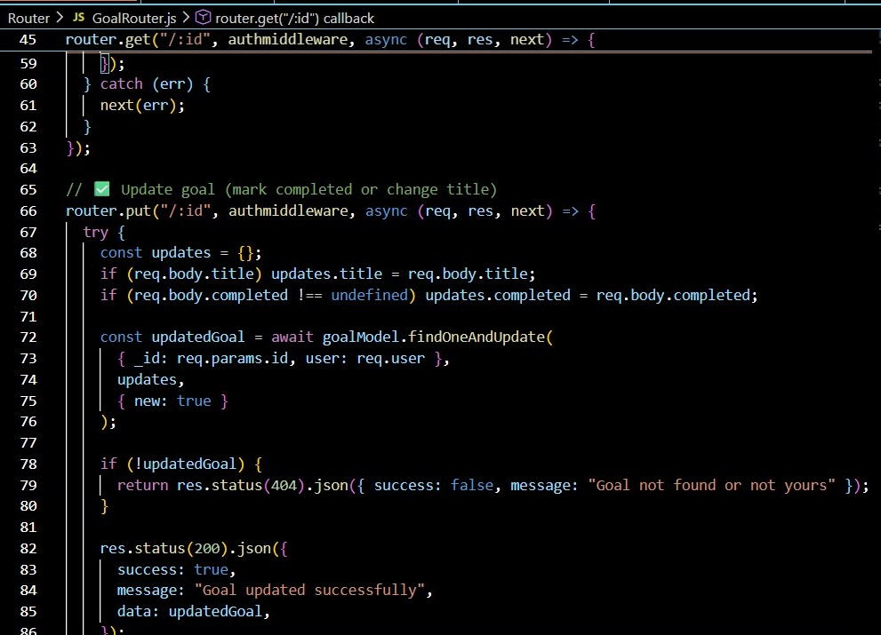

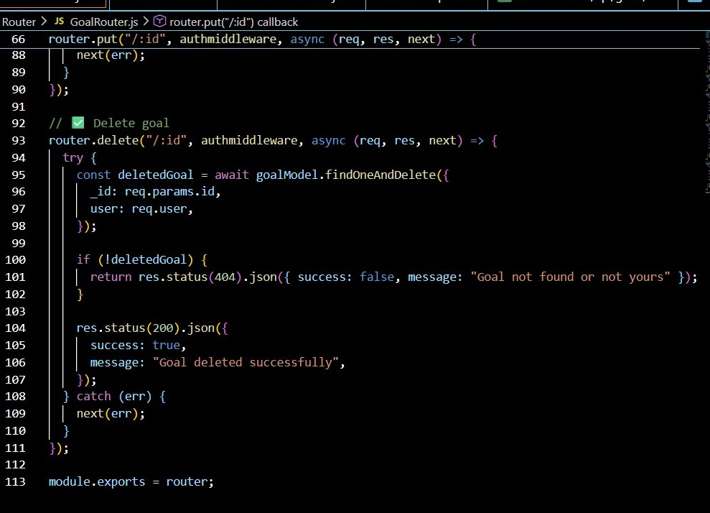
10. Added AuthMiddleware.JS
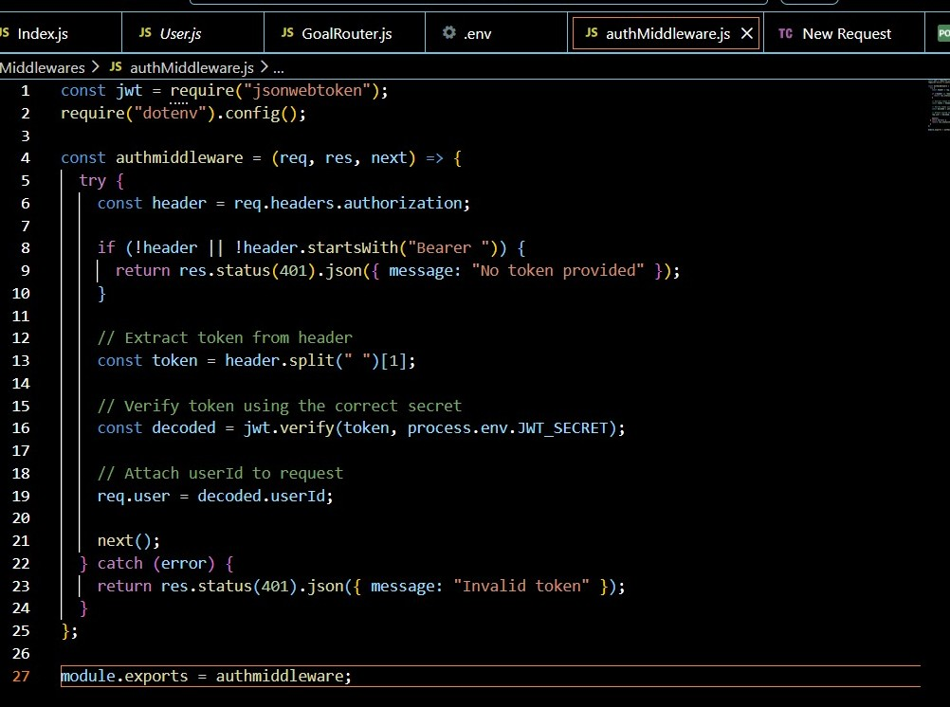

12. Added Error Middleware:
An error middleware was added to handle application errors centrally and return proper status codes and messages.

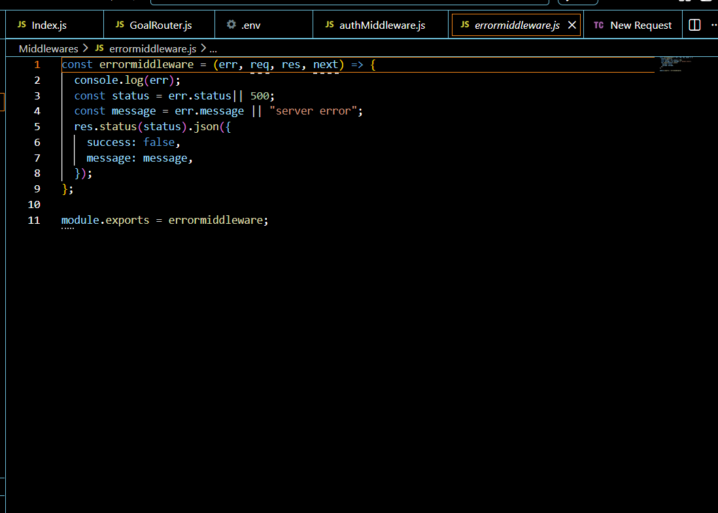
13. DATABASE DEVELOPMENT
CONFIGURE MongoDB:
● Local MongoDB
● Store connection string in .env

CREATE DATABASE CONNECTION

Index.js file:
● Use mongoose.connect()


14. CREATE SCHEMA AND MODELS
User Schema
The User Schema defines the user data structure with name, email (unique), and
hashed password fields.

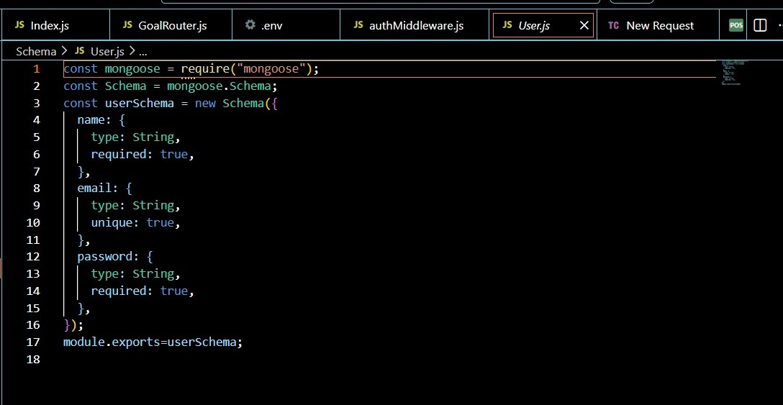

15.Goal Schema (with user Id reference)
The Goal Schema stores goal details and includes a user Id reference to associate each goal with a specific user.
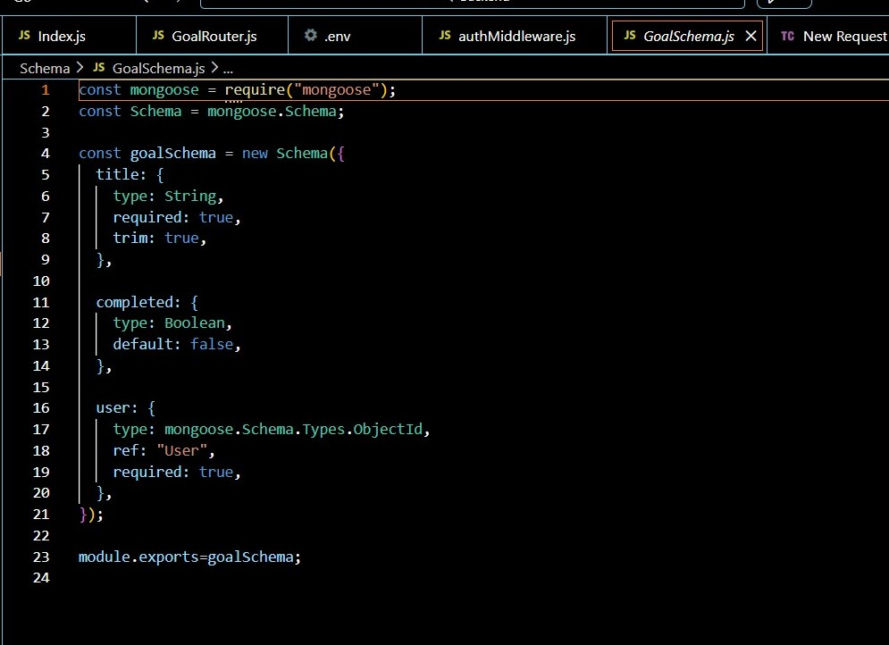

16. PROJECT EXECUTION
Project Execution Steps
1. Start MongoDB
2. Run server
3. Test APIs in Thunder Client
4. Register User
5. Login and get JWT
6. Perform CRUD operations
17. Project Output :
Successful User Registration (Signup/Login)
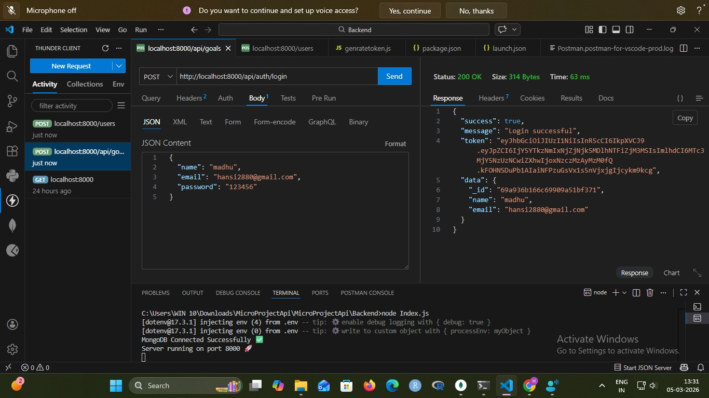

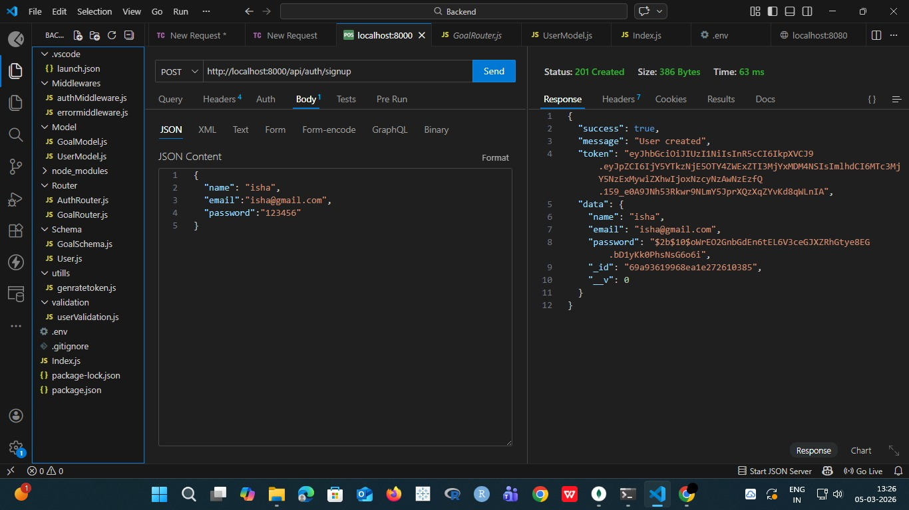

Goal Created ,Updated and Deleted Successfully
● After the login and token is generated the user give post request to api for
creating there goals and goal was save in MongoDB which was the database.

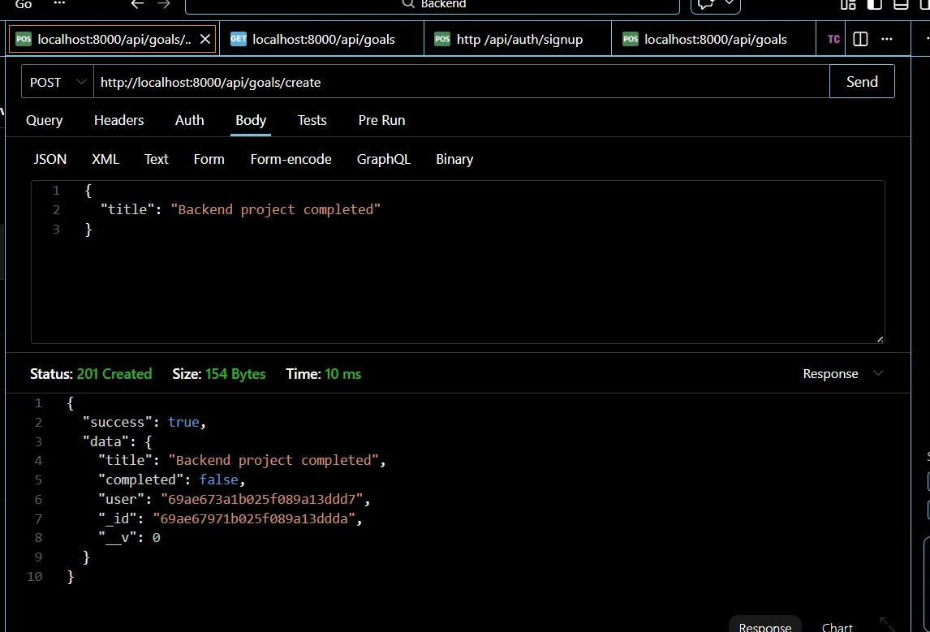

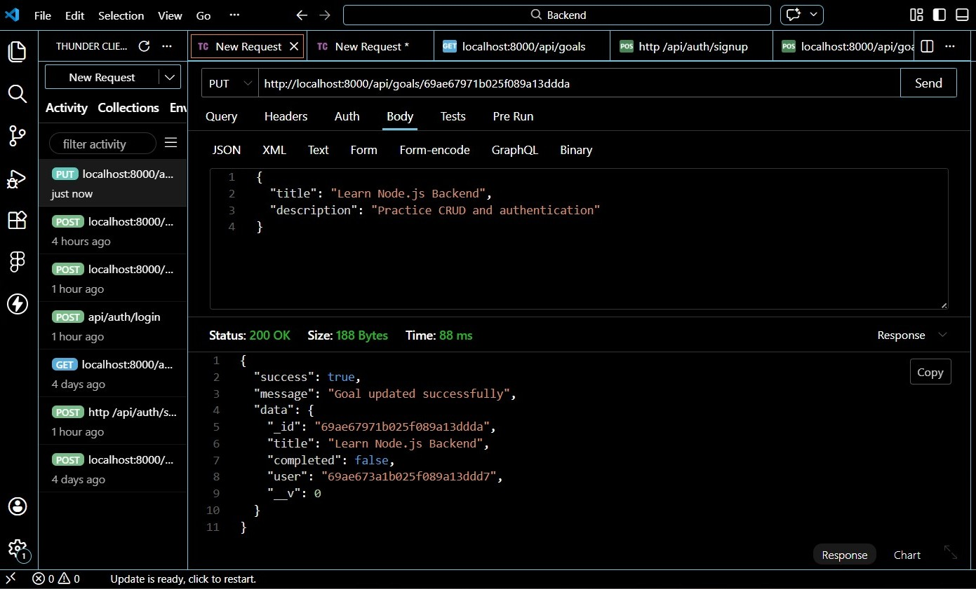

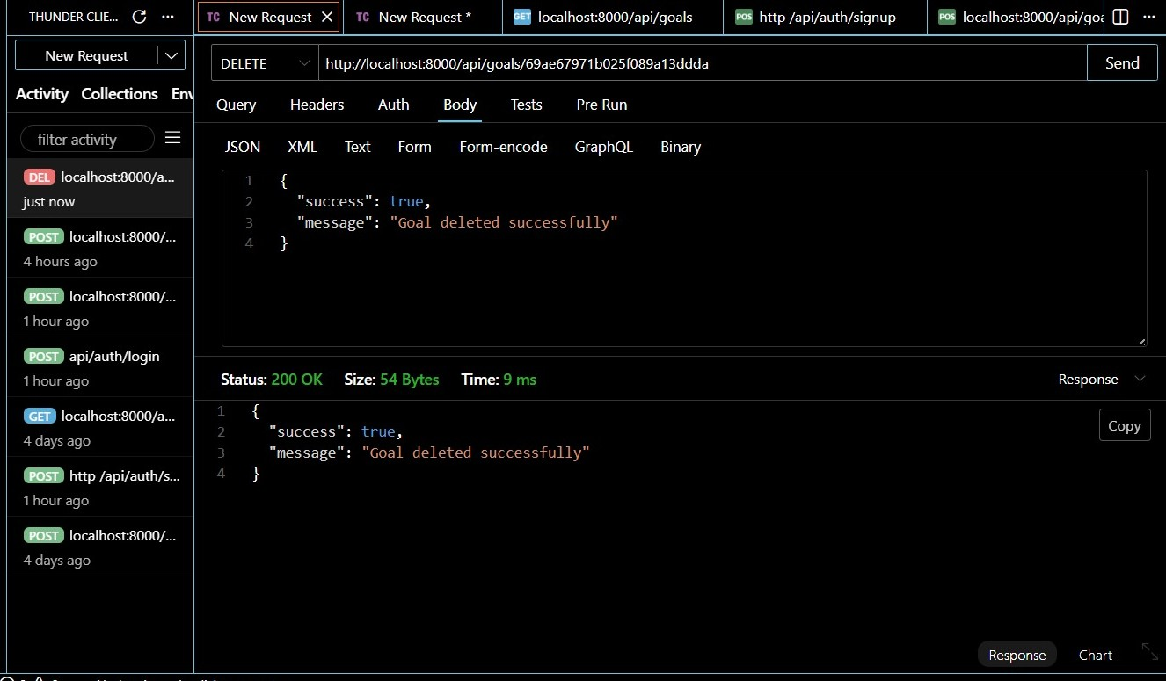

DEMO VIDEO:
VIDEO LINK: https://drive.google.com/file/d/1sbnH-Piq15tYeY6FlhY5M4foFbIaJ7u-/view?usp=sharing

